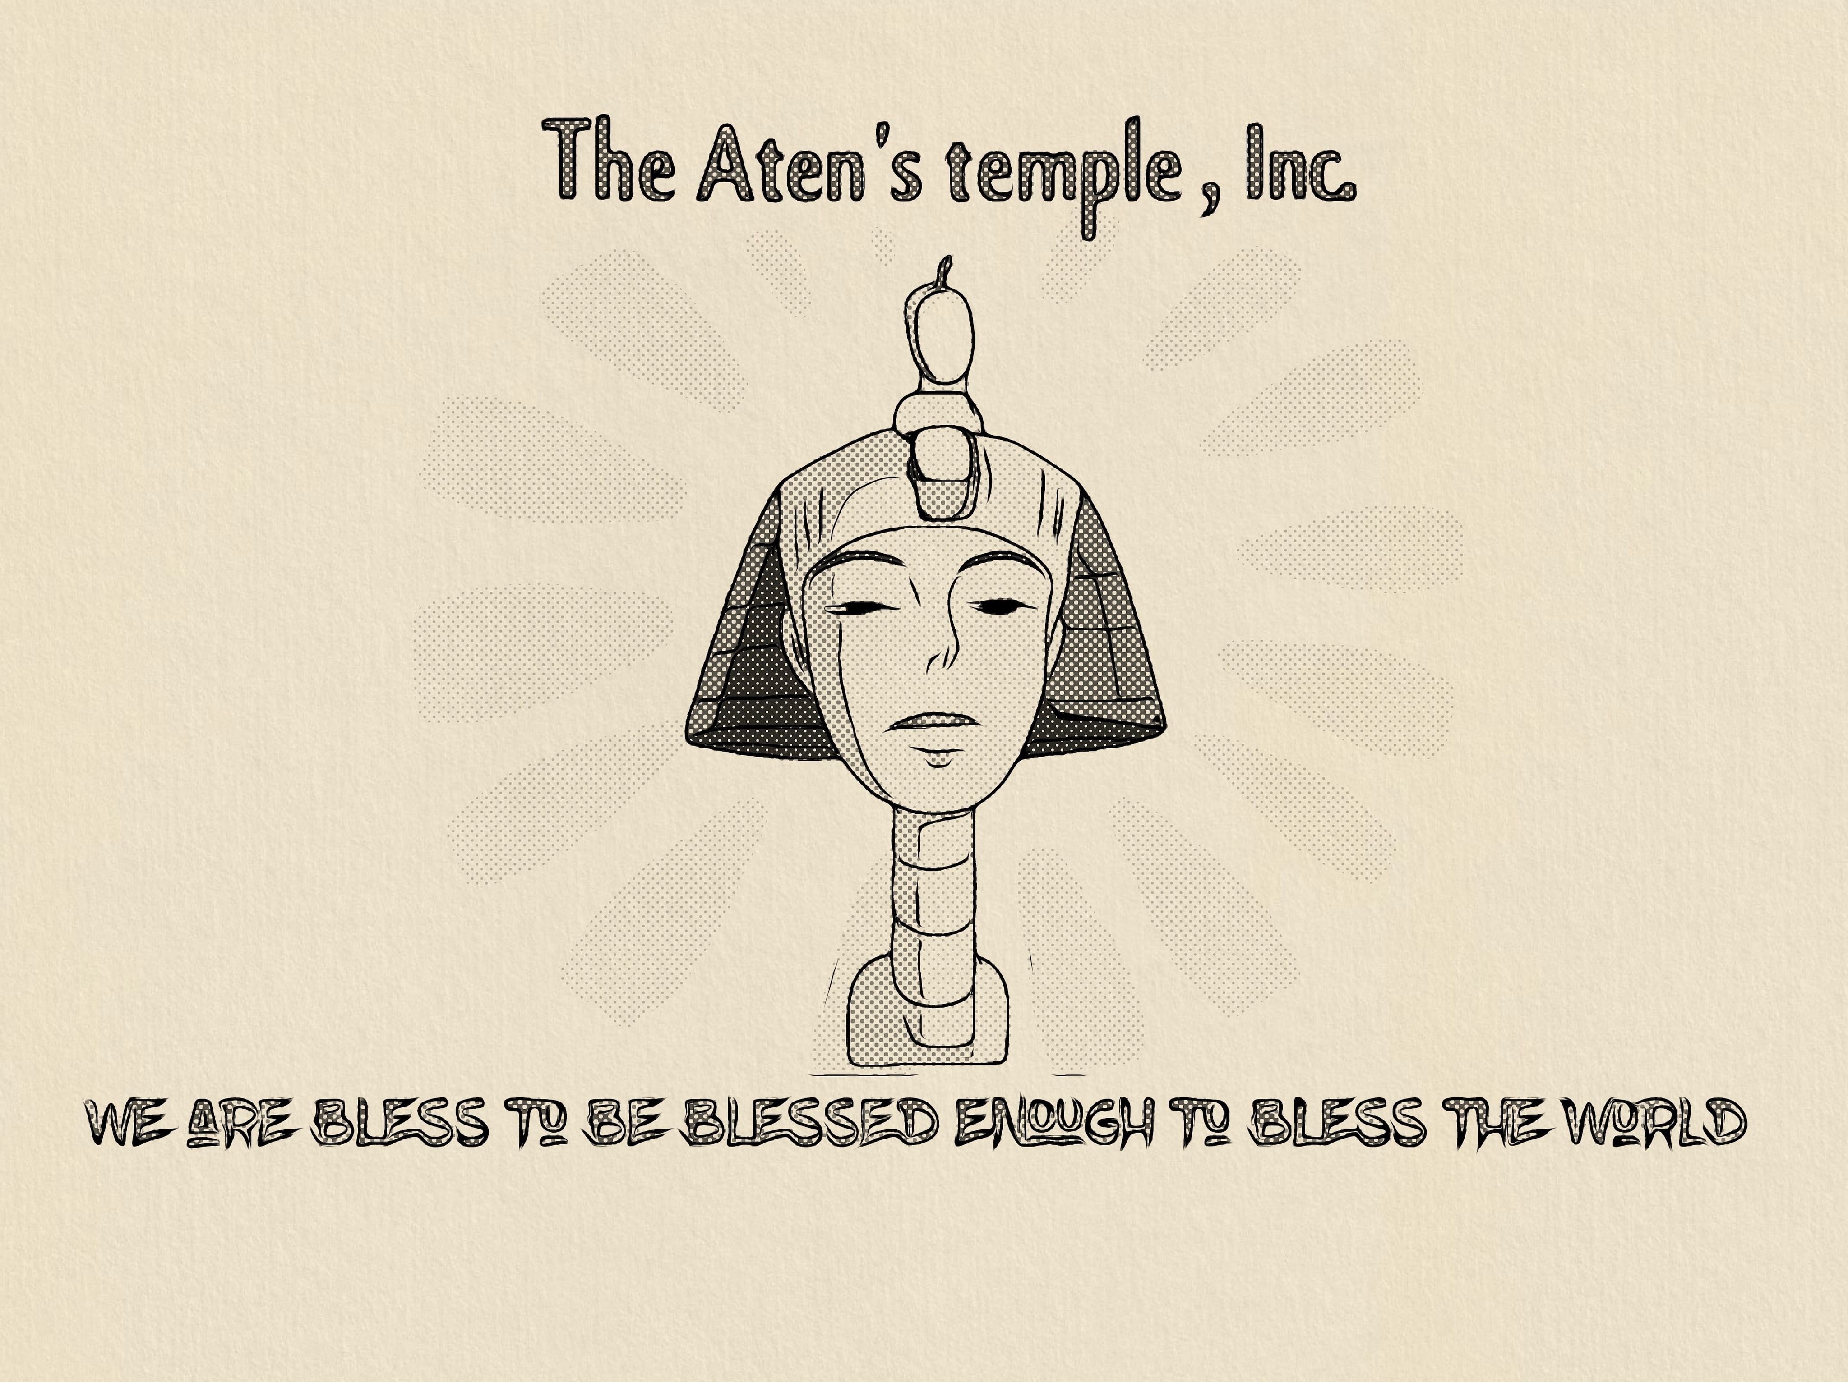
(A Sample Reading Only)
By Kevin N. Bell & Prophet Naziyr
Copyright © 2025 by (Kevin N. Bell)
All rights reserved.
No part of this book may be reproduced or transmitted in any form or by any means without written permission from the author.
Printed in US

Q: What is our mission statement, here at Yah’weh’s Temple Inc?

A: Simple: Peace, Freedom, & Justice, for All of Mankind!!!

Love us or hate us, join us, or reject us, we are still going to make our mark on the earth.

Prophets of ancient past were rejected, tortured and some even murdered for speaking the word that our Creator had blessed them with. And still we made our mark on the earth.

These messengers were hated, no one listened, no one cared. And still we made our mark on the earth.

But still God’s word has found its way into the hearts of many. Into the homes of those who barely ever read the textbook. And still we made our mark on the earth.

Inside the books left behind for discovery, are the tales we love, our imagination running wild concerning our wishes for freedom from harsh realities. Our untapped power being unleashed upon the evil that suppressed our human desire of want, and need for peace on earth. And still we made our mark on the earth.

So, we shall proof our word from the creator, by removing the veal from over the eyesight, removing the ear plugs from the earlobes, and removing the mental barrier from the minds of those who know and believe that there is only ONE GOD of earth and the cosmos! And still, we will make our mark on the earth.

We will not allow those who have been trained to learn, love, and pass down to us their hideous ways in hiding from us our God anymore! And still, we will make our mark on the earth.

Their tactics will be exposed! And scorched with the rays of our creator of monotheism. There is only ONE GOD! And still, we will make our mark on the earth.

And this is what it was since we were called out of Egypt! The rest of the gods are idols, and nonexistent Gods even! So, fear not the unseen, unspoken, and the unadvised… because if it is not real, no see, no touch, no feel, then we will not allow it to rob and seal our truth, of all reality that our God is forever with us! And still, we will make our mark on the earth.

Aten Guides, Amen!

Now allow us to go over the basics of what one may want to know when becoming a “Naziyr: Devoted One to Aten”

We shall go over the covenant prayer once a day and the affirmation 3 times a day.

Sunrise: Covenant, and then Affirmation.

Afternoon: Affirmation.

Sunset: Affirmation.

Note: Prayers may be said any other times as need. Including nights.

We want to honor the 10 earlier Covenant Lessons of Atenism in truth. As well as learn the 10 new Covenant Lessons of Atenism, taught by the Prophet “Naziyr”

Now allow us to go over the five basic principles one may want to learn as a Naziyr: devoted one to Aten.

And they are as follows:

- Who is our God?

- Aten who later became,
Pharaoh: Male & Female “Aten in the flesh”
Akhenaten: Aten’s creation is effective for him.
& Father/God of Abrahamic Scripture.

- What is our God?

- The “Pure Traveling Light” or PTL

- When do we see Aten?

- Daylight hours.

- When should one praised God?

- Anytime is okay, but best times are when God is visible.

- What is our End-times Handbook

- The Book of “The Prophet Naziyr”.
- The Mysterious Scroll of Akhenaten.
- The Holy Book of the Prophesied Counselor: Books 1 & 2.
- Naziyr: Devoted One’s 2 Aten “Study Guide”
- Aten: The Book of Sermons & The Return of Christ
- The Moment of Clarity
- The Creation of Monotheism

And that will wrap it up our reading. We hope and pray that you got a little more information on our mission here at Yah’weh’s Temple Inc.

Rehobot! And Aten Guides! Amen!!

“The ancient stories that are told to us are based on the lives of Kings, Queens, and Pharaohs; some are even of folktales of ancient past.” —Kevin N. Bell

THE END

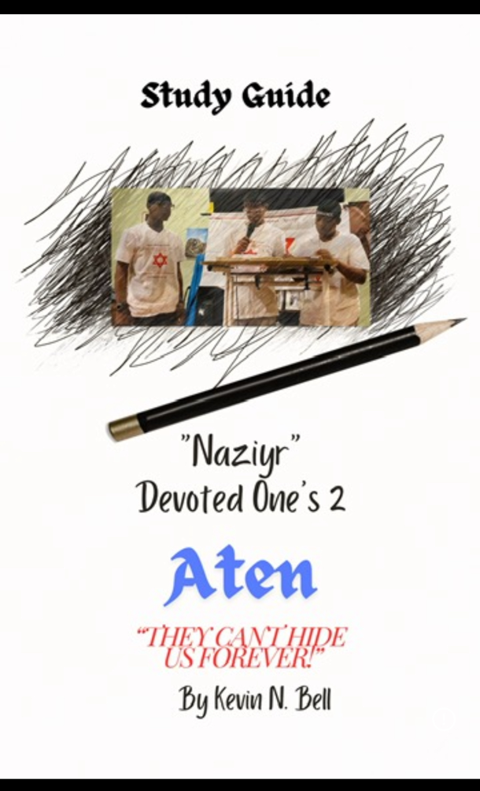
Order @ Amazon.com

