1 of 6

“We Give, Teach, & Sell Books!”
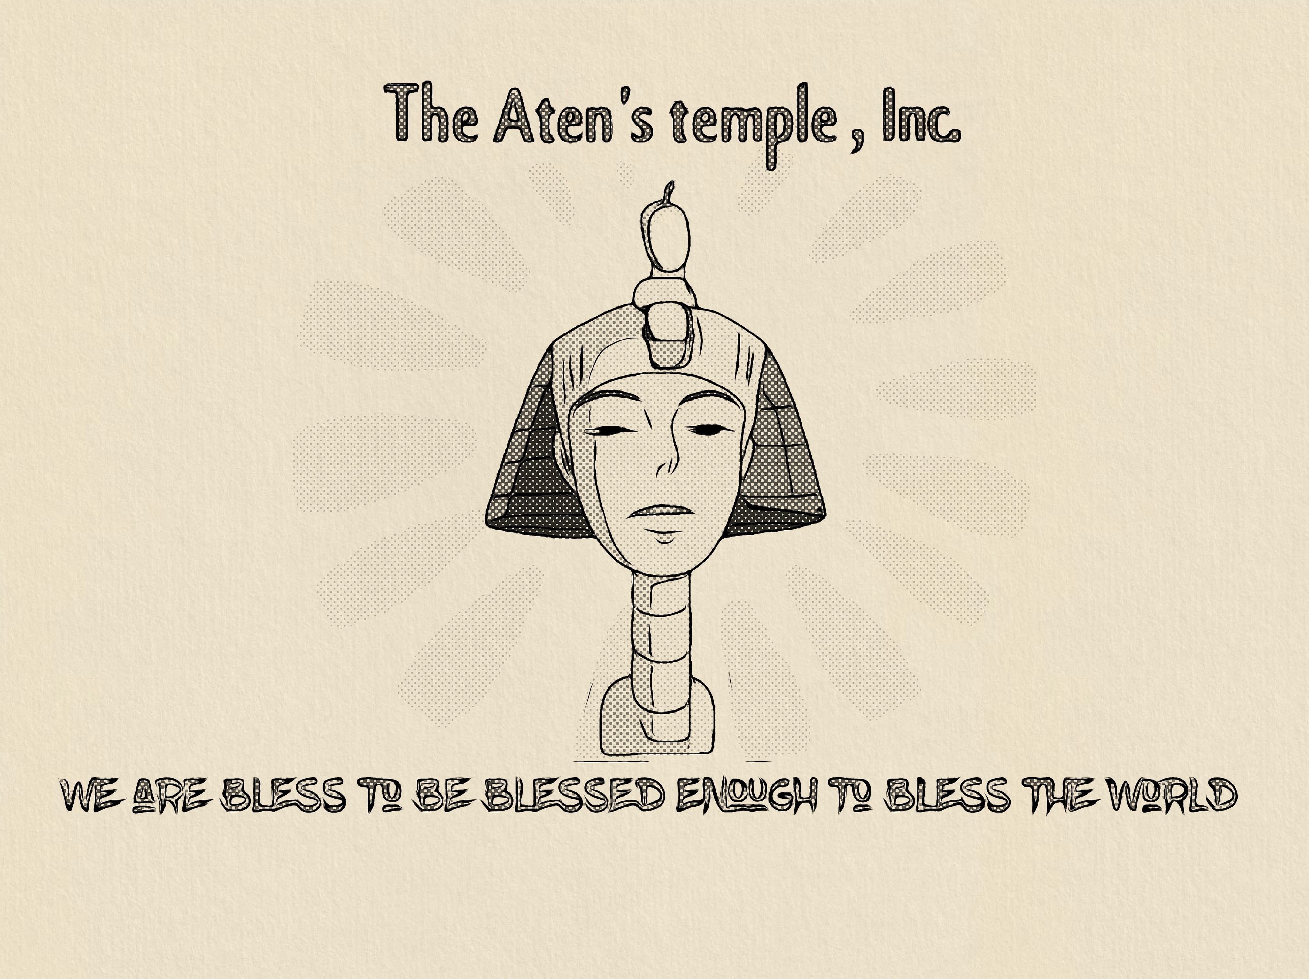

Naziyr & Asia T. Bell, President & Vice President

"Prophet Naziyr" and "The Aten's Temple, Inc." appear to be associated with an organization that describes itself as a non-profit, faith-based organization. They aim to assist those in need of resources and offer education on monotheism and its history in religious practice. The organization's website, Yah'weh's Temple, Inc. (also referred to as The Aten's Temple), indicates that Prophet Naziyr and his wife, Queen Asia, began holding spiritual meetings at their home in West Philadelphia. "The Aten's Temple, Inc." was established from these gatherings. The organization states its mission is to "Give, Teach, & Sell Books!" The website also mentions videos discussing "Who is Prophet Naziyr?" and explaining their teachings.
Please note: This was part of a religious reform initiated by Pharaoh Akhenaten (circa 1353–1336 BCE). While the name "Aten's Temple, Inc." may draw inspiration from this ancient worship, the organization appears to be a separate, modern entity based in Philadelphia, Pennsylvania.

According to their website, The Aten's Temple, Inc. (formerly referred to as Yah'weh's Temple, Inc.) engages in the following activities:
• Giving resources to those in need: This suggests providing assistance in various ways to support individuals facing hardship or lacking essential resources.
• Teaching and education: The organization aims to educate people about monotheism and its historical context within religious practices.
• Selling books: This activity may support their mission by providing materials for educational purposes and potentially generating funds for their charitable work.
The website also mentions that the organization arose from spiritual meetings held at the home of Prophet Naziyr and Queen Asia, where they experienced a premonition about getting involved in charity work. Their stated mission revolves around giving, teaching, and selling books as a means to help others and spread their message. The organization is explicitly identified as a non-profit entity dedicated to these activities.
Giving one example of books provided.
Based on the provided information, a specific example of a hidden myth addressed in The Holy Book of the Prophesied Counselor involves the use of "Morning Star (Attar or Star of Satan)" by Jesus in a way that Prophet Naziyr considers a pagan symbol.
This claim implies that traditional interpretations of Jesus' teachings and actions related to the "Morning Star" are considered inaccurate or misleading by Prophet Naziyr. He suggests that this symbol, which he associates with a pagan deity or concept, has been misconstrued in a way that doesn't align with what he believes to be the original or true meaning of scripture.
It's important to understand that Prophet Naziyr arrives at his interpretations by comparing his personal dreams and revelations with existing scriptures, seeking to "unravel the truth hard to swallow by Scholars around the world". He aims to present what he considers to be the "word of God in its most original form".
Note: This is one specific example mentioned in the summaries of the book. The book likely addresses other areas where Prophet Naziyr believes there are hidden myths or misinterpretations within traditional religious teachings
Based on the available information, The Aten's Temple, Inc. appears to use the term "Aten" in a context suggesting it represents a singular, supreme deity, similar to the ancient Egyptian Atenism initiated by Pharaoh Akhenaten. The organization's focus on monotheism and Prophet Naziyr's emphasis on revealing a "correct interpretation" of scripture suggests a departure from mainstream Christian beliefs, including the doctrine of the Trinity.
However, the exact representation or understanding of Aten within The Aten's Temple, Inc. teachings is not explicitly detailed in the provided snippets. Books may describe the historical context of ancient Egyptian Atenism, where Aten was depicted as a solar disk with rays ending in hands. This representation symbolized Aten's role as the source of light, warmth, and life, and was associated with creation and sustenance. Aten was considered a cosmic force, representing light without darkness, presence without absence, and unity without multiplicity.
It is possible that The Aten's Temple, Inc. interprets Aten in a similar way, emphasizing its singular and all-encompassing nature. However, without more specific information from the organization itself, the exact details of how Aten is understood within their teachings remain unclear. It is important to remember that while the organization shares the name and some thematic similarities with ancient Atenism, it is a modern entity based in Philadelphia, and its teachings may have unique interpretations and divergences from historical practices.
Based on the available information, it's difficult to provide a specific example of a hidden myth about God's nature that Prophet Naziyr addresses in detail within The Holy Book of the Prophesied Counselor. However, some potential areas can be inferred based on the book's description and the organization's name.
• The Trinity: The Aten's Temple, Inc. appears to deviate from the mainstream Christian doctrine of the Trinity. This would mean that Prophet Naziyr, guided by his revelations, likely challenges the traditional Trinitarian understanding of God's nature and proposes an alternative perspective.
• Aten as the Source: The connection to Atenism, the ancient Egyptian worship of the sun disk Aten, could indicate that Prophet Naziyr's revelations lead to emphasizing Aten as the primary or singular manifestation of the divine. This would likely contrast with mainstream Christian views that acknowledge God in three persons.
• Jesus' Subordinate Role: While Prophet Naziyr's book discusses Jesus' role in salvation, it also emphasizes his unique approach and the importance of his messenger in the end times. This focus might suggest a perspective where Jesus is seen as having a subordinate role to God, unlike the Trinitarian view where Jesus is co-equal with God the Father.
In essence, a potential "hidden myth" addressed by Prophet Naziyr could be the idea that God is a Trinity of co-equal persons. His revelations likely lead to a different understanding of God's nature, possibly emphasizing Aten as a single, supreme deity, or a conception of the divine that doesn't align with traditional Trinitarian theology.
It's important to reiterate that these are inferences based on the available information. To fully understand Prophet Naziyr's specific perspective on "hidden myths" about God's nature, a direct examination of The Holy Book of the Prophesied Counselor or other materials published by The Aten's Temple, Inc. would be necessary.
Kevin N. Bell's teachings and writings
Kevin N. Bell, also known as "The Prophet Naziyr", is an author who has written several books based on his spiritual experiences and interpretations of religious texts. He asserts that he has received dreams and revelations from God that often contradict conventional teachings, prompting him to seek the true meaning behind scriptures and uncover hidden myths.
Key themes and teachings
• Reinterpreting Scripture: Bell's works aim to provide a "correct interpretation" of ancient scriptures, claiming they were altered to fit modern organized religions.
• The uniqueness of Jesus Christ: His book "The Holy Book of the Prophesied Counselor" delves into Jesus Christ's distinct approach to saving God's people.
• The Atenism Covenant: Bell explores a concept he refers to as "The New Atenism Covenant" in his works, including "The Holy Book of the Prophesied Counselor 'The Duology'".
• End-time prophecies: Bell discusses the end-times, including the return of the savior, the battle against Satan and the Antichrist, and the role of the 144,000 mentioned in the Book of Revelation.
• The Mystery of God and Humanity's Purpose: Bell's writings also delve into the fundamental questions surrounding the nature of God and the purpose of humankind's existence on Earth.
• Personal Faith: Bell's teachings emphasize the importance of having a personal faith, rather than relying on the faith of others like parents or pastors.
• Seeking God and Quiet Time: Bell encourages seeking God, having quiet time with Him, and trusting in Him for provision and protection.
Works and stories
Some of Bell's notable works include:
• The Holy Book of the Prophesied Counselor: Explores Bell's interpretations of revelations and the purpose of scriptures.
• The Prophet Naziyr: Chronicles the author's journey and spiritual experiences during a major pandemic.
• Aten: The Book of Sermons: Examines the concept of Aten and its ancient worship practices.
• "Naziyr" Devoted Ones 2 Aten-Study Guide: A study guide for his book about Aten.
• The Creation of Monotheism: A book discussing the origins of monotheistic belief.
It is important to note that Bell's writings offer a unique perspective on religious texts, which may differ significantly from established theological interpretations.
While a comprehensive list of all his reinterpretations is unavailable, based on the provided search results, a few examples can be drawn:
1. Laws of Moses as "Human-Rules"
• In a video, Bell asserts that Jesus stated, "the Laws of Moses were human-rules!" This directly challenges the widely held belief that the Law of Moses originated directly from God. Bell implies that these laws were implemented by humans and not necessarily a direct divine command. In this video, Bell discusses his reinterpretation of the Laws of Moses.
2. Revelation and the 144,000
• Bell's writings address the concept of the 144,000 mentioned in the Book of Revelation. He describes them as the "chosen ones" who are not the Bride of Christ but will rule alongside him. This contrasts with interpretations that consider the 144,000 to be a symbolic representation of all believers. Bell also suggests that this group comprises individuals who may not have fully embraced the "revelation of their hour" but demonstrated faith and dedication.
3. Atenism Covenant
• Bell introduces the concept of "The New Atenism Covenant" in his works, including his book The Holy Book of the Prophesied Counselor. This suggests a unique interpretation of the divine covenant, possibly drawing connections to the ancient Egyptian god Aten and creating a new framework for understanding the relationship between God and humanity.
It is crucial to note that these reinterpretations differ significantly from established theological viewpoints. Bell's work is based on his personal experiences, dreams, and revelations, which he believes offer new insights into religious texts. Individuals seeking to explore Bell's teachings should approach them with a critical and discerning mindset, comparing them with traditional interpretations and other theological perspectives.
How Kevin N. Bell connects Atenism to his covenant concept?
Kevin N. Bell, also known as "The Prophet Naziyr," in his writings and teachings, draws upon the historical and religious movement of Atenism in ancient Egypt to inform his concept of a "New Atenism Covenant." While the specifics of his interpretation are unique, some connections can be made based on the provided information.
1. Monotheistic or henotheistic focus
• Atenism, as promoted by Pharaoh Akhenaten, centered on the worship of a single deity, Aten, represented by the sun disk.
• Bell's "New Atenism Covenant" seems to resonate with this idea of focusing on a single divine entity, potentially suggesting a return to or a new form of monotheistic or henotheistic devotion, as opposed to polytheistic worship.
2. Emphasizing a unique relationship with the divine
• Akhenaten presented himself as the sole intermediary between Aten and the people.
• Bell, as "The Prophet Naziyr," claims to receive direct revelations and dreams from God, implying a personal and unique connection to the divine that informs his teachings. This parallels Akhenaten's role in Atenism.
3. Reinterpreting and reforming religious practices
• Atenism involved a radical shift away from traditional Egyptian polytheism, including the suppression of other deities and the creation of a new capital dedicated to Aten's worship.
• Bell also calls for a reevaluation and reinterpretation of religious texts, suggesting that traditional practices may be misleading and hinting at a need for a new "covenant" to restore truth. This may be reflected in his The Holy Book of the Prophesied Counselor.
4. Covenant concept
• Traditional Atenism, as recorded by historians, did not have a clear concept of a covenantal relationship in the way that the Abrahamic religions do.
• Bell's introduction of a "New Atenism Covenant" suggests he may be reinterpreting Atenism to include a contractual relationship with the divine, potentially based on new understandings or revelations.
It's important to recognize that Kevin N. Bell's interpretation of Atenism is likely a unique blend of historical understanding, personal revelations, and reinterpretations of religious texts, and may not align with established historical or theological perspectives. One source states that Aten was hidden from common people, and only the pharaoh could communicate directly with Aten. This detail could be significant to Bell's interpretation of Aten and the associated covenant.

Thank you for reading this AI generated response about “The Aten’s Temple, Inc.”

Respectfully,
Naziyr & Asia T. Bell
President and Vice President
The Aten’s Temple, Inc.

