The New Atenism Covenant
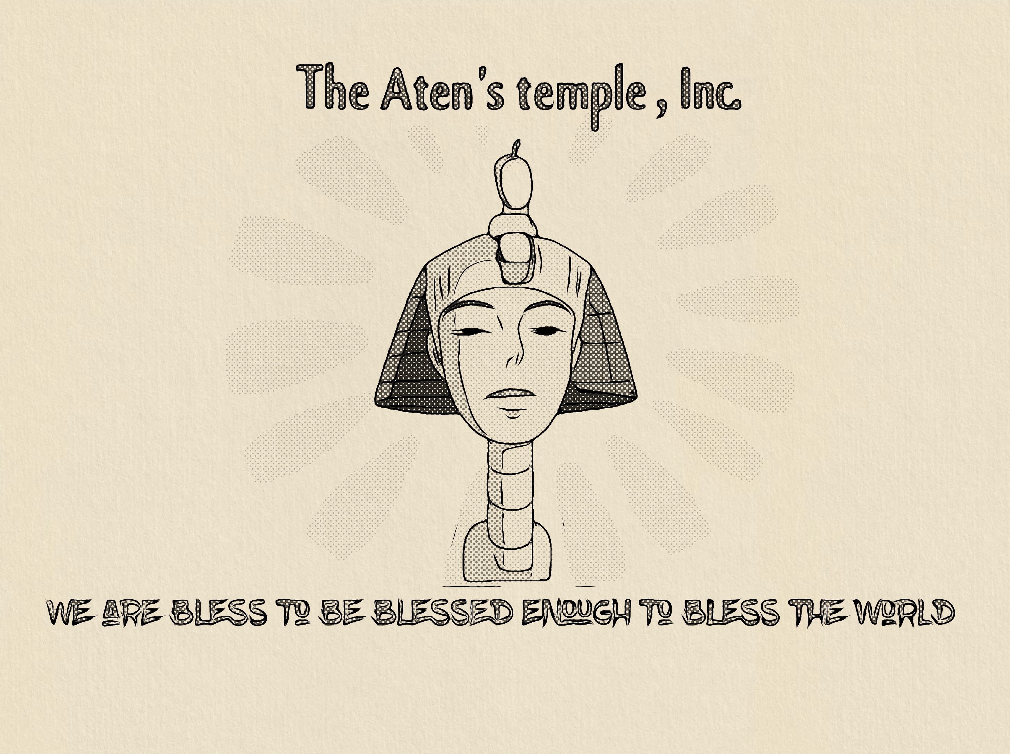

"What they gave us, they took from us,
and with it, changed us.
And, the "Aten" will take it back,
correct us, and with it, restore us."
—Kevin N. Bell

Lessons of our New Atenism Covenant
Two prayers are first announced when becoming A “Naziyr” devoted one to Aten.
The Covenant Prayer # 1 (Opening)
Yah’weh is the most magnificent thing, seen and unseen.
We bear witness that nothing would exist if “Yah’weh” had not created it.
Please, forgive us for our past sins, do away with our evil,
and guide our souls with the righteous ones;
the men of prophecy.
Give us that which you had promised us,
the New Covenant prophecy,
by way of past scripture;
and do not disgrace us in the end times.
Surely you do not break any promises.
“Yah’weh Saves!” Amen.
The Affirmation Prayer # 2 (Closing)
We are in the love of Yah’weh, and Yah’weh love is in us.
We are a part of Yah’weh, and Yah’weh is a part of us.
We are one with Yah’weh, and Yah’weh is one with us.
We can be all that we wish in Yah’weh,
as long as our wish is to stay in Yah’weh,
we are never alone.
Yah’weh is, we are.
Yah’weh can, we can.
Yah’weh does,
We do.
"Yah’weh Saves!" Amen.

& with anointing oil, the Lead Counselor shall say, “May the Aten accept you into his new covenant!” And they both shall say, and repeat that, “Yah’weh Saves! Amen!!”

note: Once the devotee accepts the covenant, they will from there on be allowed to use the name “Aten” instead of “Yah’weh” during their prayers to Him.

Basic Principles a Naziyr: devoted one shall learn within our covenant with Aten

Q#1: Who is our God?

A: The Aten: Who later became Akhenaten; Father of holy scripture (Psalm 84:11; Psalm 50:1; Psalm 104:2; Psalm 113:3; Matthew 13:43; Surah 2:97; & Surah 24:35).

Q#2: What does our God name mean?

A: The Aten “Pure Traveling Light” and Akhenaten is his representative:
Meaning “Aten is We (Genesis 1:3-5; Genesis 2:7; & Genesis 1:26-28).”

Q#3: What is our conduct?

A: We have 10 Lessons. And they are as follows;
- Serve “Aten” only.
- Rebuild his nation through its lessons.
- Remember “Akhenaten.”
- Remember the New Covenant
- Lessons are from Aten Only.
- Make not allies with nonbelievers.
- Blast not the name “Aten or Akhenaten.”
- Eat to live (healthy living).
- Have not an ungrateful relationship.
- Help gather the council of Atenism.

Q#4: What about the earlier 10 lessons (Exodus 20:1-17), Aten gave his son Amenhotep IV (Exodus 4:22), when he led his nation out of Egypt (Hosea 11:1)?

A: They will be honored in truth. And they are as follows.
- Have no gods besides Aten.
- Do not make another god besides Aten.
- Do not shame the name Aten.
- Thou shall remember the 7 days of restoration (Sunday — Saturday, then a cease of days in the week & refresh of days) and to keep it holy. (Note: not a day of rest.)
- Honor your mother and father.
- Thou shall not kill.
- Thou shall not commit adultery.
- Thou shall not steal.
- Do not bear false witness against your neighbor.
- Thou shall not want or take possession of another person's belongings.

It is highly recommended that each new devotee
obtain a copy of the Study Guide.

Respectfully Yours,

Naziyr & Asia T. Bell

President & Vice President
The Aten’s Temple, Inc.
Email address: theatenstempleinc@gmail.com
Website: https://www.theatenstempleinc.org

